Write a Scala application to find the Nth digit in the sequence.

○ Write the function using standard for loop

○ Write the function using recursion

For loop :-

Code

def fibLoop(n:Int):Int ={

if(n<2) 1 else {

var(a,b) =(1,1)

var c =a+b

for(i <- 2 to n)

{

a=b

b=c

c=a+b

}

c

}

}

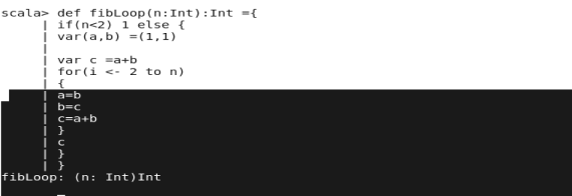







2) Recursion

Code :

def fib( n : Int) : Int = {

def fib_tail( n: Int, a:Int, b:Int): Int = n match {

case 0 => a

case _ => fib_tail( n-1, b, a+b )

}

return fib_tail( n, 0, 1)

}

